## 1. Introduction

Identity verification is a mandatory step in eligibility determination for programs such as SNAP, TANF, and Medicaid. Currently, workers manually review documents in the e-Folder, identify the type of document (e.g., Driver’s License, Passport, Alien Registration Card, Hospital Record, or Other Acceptable ID), and select the appropriate option from the dropdown in the system. Verification relies on checking details such as Name and Date of Birth, with additional factors like Address, Photo, ID number, and Expiry date playing supporting roles. In some cases, verification can also depend on external matches, such as a Social Security Administration (SSA) verification, or require a combination of two or more documents when a single primary document is not available.

The AI-augmented plan automatically classifies documents from the e-Folder, extracts key fields (Name, DOB, ID#, Expiry, Photo), and applies program-specific rules (SNAP, TANF, Medicaid) to suggest the correct identity verification option.  
Workers review the AI’s suggestion with confidence scores and can Accept, Override, or Reject. Once approved, the system updates the dropdown and stores the document reference for audit, ensuring speed, accuracy, and compliance.

## 2. Current Manual Process

### 2.1 Accepted Document Types (Dropdown Options)

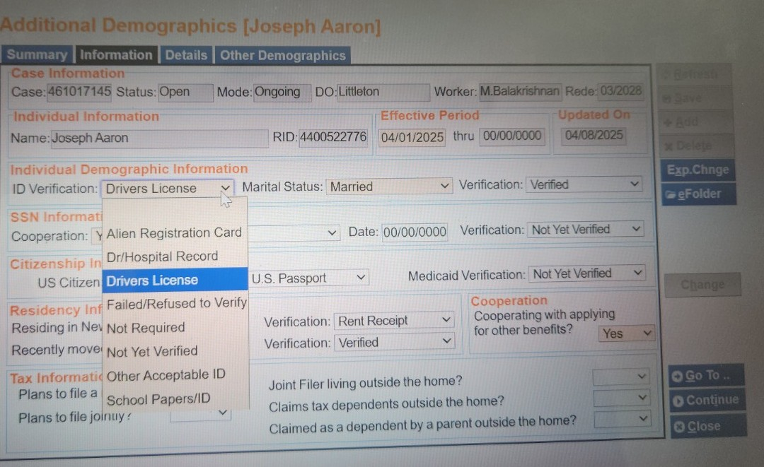

During eligibility determination, case workers select the type of document used for identity verification from a predefined dropdown menu. The available options are:

* **Driver’s License**
* **Dr/Hospital Record**
* **Alien Registration Card**
* **Other Acceptable ID**
* **School Papers/ID**
* **Failed/Refused to Verify**
* **Not Required**
* **Not Yet Verified**

These categories cover the most common forms of identification presented by applicants, as well as fallback options when primary identification is unavailable.

### 2.2 Documents Under Each Type

Each dropdown value corresponds to specific types of documents that can be used for identity verification:

* **Driver’s License**  
  Includes state-issued driver’s licenses and REAL ID cards. These documents usually contain the applicant’s photo, full name, date of birth, address, and an expiration date. They are widely accepted as a primary identity document across all programs.
* **Dr/Hospital Record**  
  Includes medical records such as hospital admission forms, clinic visit notes, or insurance cards from healthcare providers. These documents are generally used when children under 19 do not have formal photo IDs. They may show the child’s name, DOB, and sometimes address or parent/guardian details.
* **Alien Registration Card**  
  Refers to the U.S. Permanent Resident Card (Green Card, Form I-551) and other Department of Homeland Security-issued alien registration documents. These documents not only establish identity but also immigration/residency status.
* **Other Acceptable ID**  
  A broad category that covers less common or secondary forms of identification, such as:
  + Voter registration cards
  + State, federal, or local government-issued ID cards (non-driver IDs)
  + School ID cards with a photo
  + Tribal IDs or Certificates of Degree of Indian Blood (with a photo)
  + U.S. Military dependent ID cards
  + U.S. Coast Guard Merchant Marine cards
  + Employer-issued ID cards
  + Legal documents such as diplomas, marriage certificates, divorce decrees, or property deeds (used in combination with other IDs)
  + **Wage stubs** (accepted under SNAP only)
* **School Papers/ID**  
  Includes report cards, school enrollment forms, daycare records, or school-issued IDs. These are primarily used for verifying the identity of minors who may not yet have government-issued photo IDs.
* **Failed/Refused to Verify**  
  Used when the applicant is unwilling or unable to provide verification, or when provided documents do not meet the verification requirements.
* **Not Required**  
  In some cases, identity verification may be waived according to program policy. For example, certain beneficiaries (such as SSI recipients) may already be verified through federal databases, making physical documentation unnecessary.
* **Not Yet Verified**  
  The default status for a case before identity verification has been completed. Workers update this status once a valid document (or combination of documents) has been reviewed and approved.

### 2.3 Fields Verified

When reviewing a document, workers focus on key fields that can reliably establish identity. The required or optional fields vary by document type and program rules:

* **Always required**
  + **Name** → Must match the client’s record in the case management system.
  + **Date of Birth (DOB)** → Must also match the case record.
* **Sometimes required**
  + **Address** → Helpful for confirmation, though not always mandatory for identity verification.
  + **Photo** → Used for visual confirmation that the document belongs to the applicant.
  + **Document number** → Such as driver’s license number, alien registration number, or student ID number, used for record-keeping and validation.
  + **Expiration date** → Ensures the ID is current and valid (applies to licenses and Alien Cards).
* **SSA Verification**  
  The system can attempt a Social Security Administration (SSA) cross-match using SSN, name, and DOB. **We can only use other acceptable id’s only when they are SSA verified?**

### 2.4 Combination Rules & Special Cases

Not all documents can independently verify identity. Some require combinations, while certain groups of applicants qualify for exceptions:

* **One primary document is sufficient**  
  Documents like a Driver’s License or an Alien Registration Card are strong enough on their own to verify identity.
* **Two-document rule**  
  If only weaker forms of identification are available (such as a diploma, voter registration card, or property deed), workers must use at least two documents together to establish identity. Both must include consistent identifying details such as name and DOB.
* **Children under 19**  
  Children often do not have government-issued photo IDs. In these cases, **School Papers/ID** and **Hospital/Clinic Records** are acceptable forms of identity proof.
* **SNAP program exception**  
  SNAP is the most flexible program. A **wage stub** alone is considered sufficient to verify identity, even though it would not be accepted in TANF or Medicaid.
* **SSI/Medicare recipients**  
  If an applicant already receives SSI or Medicare, identity verification may be completed through cross-match results, without the need for physical documents.
* **Affidavit fallback**  
  If no documents are available, an affidavit signed under penalty of perjury by someone familiar with the applicant can be accepted. This affidavit must include identifying details such as age, sex, race, height, weight, eye color, or address.

## 3. Program-Specific Rules

Identity verification requirements vary slightly across different programs. While many of the same document types are accepted, each program has specific rules that determine which documents are valid, when multiple documents are needed, and when exceptions apply.

### 3.1 SNAP (Supplemental Nutrition Assistance Program)

* **Broadest acceptance of documents**  
  SNAP allows a wide range of documents to be used for identity verification, including some that are not accepted by TANF or Medicaid.
* **Accepted documents include:**
  + Driver’s License
  + Alien Registration Card
  + School Papers/ID (for children)
  + Hospital or Clinic Records (for children)
  + Other Acceptable ID (such as voter cards, government IDs, tribal IDs, employer IDs, and military dependent cards)
  + **Wage stubs** (unique to SNAP – accepted as identity proof, even if no photo ID is available)
* **Fields verified:**  
  Primarily **Name** and **Date of Birth**, with optional checks of Address and Photo where applicable.
* **Special rules:**
  + If the applicant already receives SSI, this can substitute for identity verification.
  + SNAP allows more flexibility for individuals who cannot present primary photo IDs.

### 3.2 TANF (Temporary Assistance for Needy Families)

* **Stricter acceptance than SNAP**  
  TANF generally requires a government-issued photo ID or a combination of secondary documents to establish identity.
* **Accepted documents include:**
  + Driver’s License (primary)
  + Alien Registration Card (primary)
  + School Papers/ID (for children)
  + Dr/Hospital Record (for children only)
  + Other Acceptable ID (only when combined with another valid document, such as diploma + voter card)
* **Fields verified:**
  + **Name** and **Date of Birth** are mandatory.
  + For photo IDs, the **Photo** is compared to the applicant.
  + Expiry date and ID numbers are reviewed to ensure the document is valid.
* **Special rules:**
  + Children under 19 may use school or medical records.
  + Two-document rule applies if no primary photo ID is available.
  + If SSA cross-match succeeds, it may satisfy identity requirements.

### 3.3 Medicaid

* **Similar to TANF in strictness**  
  Medicaid follows similar identity rules to TANF, with some additional exceptions for individuals receiving federal benefits.
* **Accepted documents include:**
  + Driver’s License (primary)
  + Alien Registration Card (primary)
  + School Papers/ID (for children)
  + Dr/Hospital Record (for children only)
  + Other Acceptable ID (with two-document rule)
* **Fields verified:**
  + **Name** and **Date of Birth** required.
  + Photo compared where available.
  + ID number and expiration checked for validity.
* **Special rules:**
  + If the individual is already enrolled in **Medicare** or receives **SSI**, identity verification is considered complete.
  + For newborns, medical records may be used until formal IDs are issued.
  + Two-document rule applies if only secondary IDs are available.

## 5. Proposed AI-Augmented Process

The proposed plan introduces an **AI-driven identity verification workflow** that automates repetitive tasks, ensures consistency with program rules, and still keeps case workers in control through a **Human-in-the-Loop (HITL)** model. The process integrates directly with the e-Folder, analyzes uploaded documents, and suggests the appropriate dropdown value for the worker to confirm.

### 5.1 Document Ingestion

* Every new file uploaded to the e-Folder is automatically routed to the AI system.
* Documents are normalized (PDF/Image) and securely stored with case metadata (case ID, document type, page count).

### 5.2 Document Classification

* The AI model classifies the document into one of the dropdown categories:
  + Driver’s License
  + Dr/Hospital Record
  + Alien Registration Card
  + Other Acceptable ID
  + School Papers/ID
* Classification ensures that the worker does not need to manually browse multiple files to determine document type.

### 5.3 Field Extraction & Matching

* Key fields are automatically extracted: **Name, Date of Birth, Address, Document Number, Expiry Date, and Photo presence**.
* These fields are matched against the case file.
  + Example: Name and DOB must match the client record.
  + Address, ID number, and expiry date are validated where applicable.

### 5.4 Rules Engine

* Program-specific rules are applied automatically:
  + **SNAP** → wage stubs allowed; broadest acceptance.
  + **TANF** → stricter; requires primary photo ID or two-document combination.
  + **Medicaid** → similar to TANF, with SSI/Medicare exceptions.
* If a single primary document (e.g., Driver’s License, Alien Registration Card) is sufficient, the AI marks the case as ready.
* If only secondary documents are available, the AI suggests valid **two-document combinations**.

### 5.5 Human-in-the-Loop Review

* Workers are presented with:
  + The document preview
  + Extracted fields
  + Suggested dropdown value
  + Confidence score and reasons (e.g., “Name and DOB exact match, ID valid, not expired”).
* Workers can **Accept**, **Override**, or **Reject** the suggestion.
* Overrides and rejections are logged for audit and model improvement.

### 5.6 System Write-Back

* Once the worker approves, the system automatically:
  + Updates the **ID Verification dropdown** with the correct value.
  + Marks the status as **Verified** (if applicable).
  + Stores a reference to the source document (e.g., e-Folder ID, page number) for audit purposes.